Captions for Nature Comms encapsulation article

When using the images please credit: “Pham et al., Nature Communications”
Images are included here just to ID the caption. Please use full quality images.

Media may contact: Kathleen at rowe@roweassoc.com if you don’t have access to them.

- Link to image
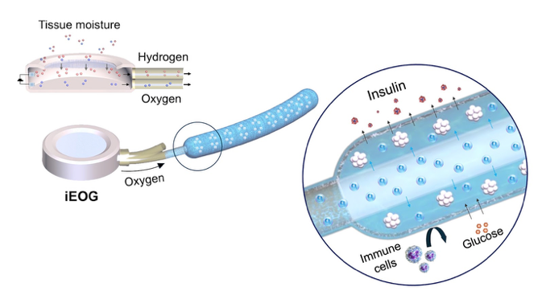

1: In this system, an electrochemical oxygen generator (iEOG) uses moisture in the surrounding tissue to create the oxygen that nourishes the cells. The cell encapsulation’s tubular pouch protects the cells from the immune system and allows nutrients in and insulin to go out into the bloodstream to regulate blood sugar.

__

5D. Link to image
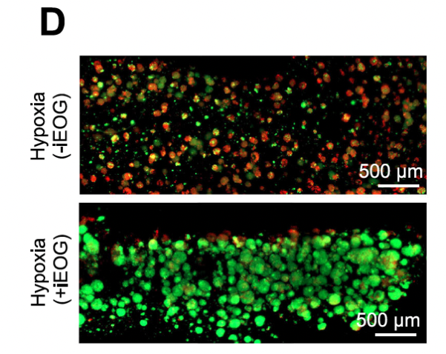

5D: The research showed that cell clusters survived in the oxygenated encapsulation system, with the live cell clusters shown in green. In the top image where oxygen is not supplemented, the clusters were not able to survive (dead cell clusters show as red).
__

6E: link to image
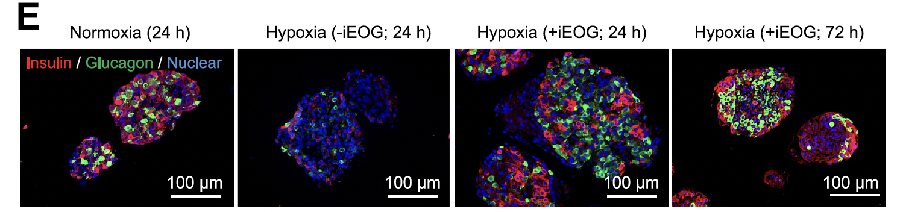

6e: The oxygenated system showed healthy cells, indicated here by typical hormonal staining. Human pancreatic islets encapsulated in this oxygenated system showed presence of the key hormone, insulin (in red) even in a low oxygen environment (image 3 and 4). The encapsulation without the supplemental oxygen (image 2), showed little hormone staining, just the nuclear proteins (blue). Image 1 is a positive control of human islets in normal incubator conditions.
__

